Database Access

Databases are software or software hardware combo that enables the programmer to easily store and retrieve data. This book is no database book but explains how to create, modify, and delete databases. We will be using a simple database engine called sqlite. There are many databases free and commercial available some of the popular ones are
- Sqlite – A popular light weight database engine which is a free software
- Postgre Sql – A full fledged free commercial database engine
- MySql – A very popular, almost free database engine.
- Oracle – Worlds most popular proprietary database engine
- SQL Server – A database engine manufactured by Microsoft, like all Microsoft products its proprietary
- Access – A light weight proprietary database engine made by Microsoft
OK lets get on with work

Installing Sqlite
Installing sqlite on Ubuntu is really easy. All you need to do is to type sudo apt-get install sqlite , this will install sqlite on your system. You can now play a little with Sqlite now,lets create a mock database, retrieve values and blah blah blah. The reader must remember that this book is not a SQL book so the coverage of SQL wont be comprehensive at any release. Te reader is encouraged to visit Sqlite website to get comprehensive documentation

Creating a Database

sqlite3 learn.db
SQLite version 3.6.22
Enter ".help" for instructions
Enter SQL statements terminated with a ";"
sqlite>

Creating Table

sqlite> create table friends(
...> id integer primary key,
...> name varchar(60),
...> phnum varchar(45),
...> email varchar(60),
...> address varchar(200));

Inserting Data

sqlite> insert into friends(name, phnum, email, address) values("Senthil", "12345", "abc@def.ghi", "Somewhere on Earth");

Reading Data

sqlite> select * from friends ;
1|Senthil|12345|abc@def.ghi|Somewhere on Earth

Updating Data

Deleting Data

Installing Ruby – Sqlite connector

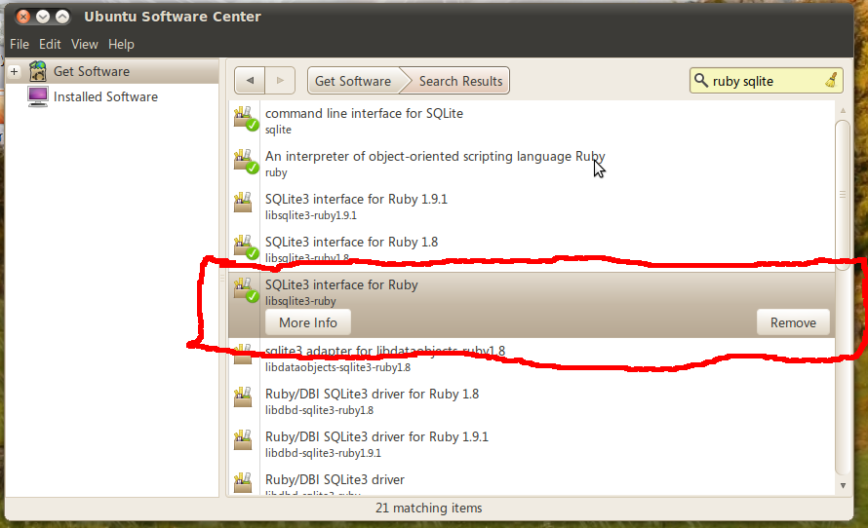

#!/usr/bin/ruby
# db_check.rb

require 'sqlite3'
puts "Ruby-Sqlite is OK" if defined?(SQLite3::Database)

Programming Sqlite with Ruby

Currently MySQL is owned by a company Oracle which itself is a competitor to MySQL. So the performance and future of MySQL is uncertain. I would like the user to use Postgre Sql instead of MySQL

